# DESIGN DRIVING CONTROLER

## Problem

The navigation package on ROS will take control the AGV by sending data include “linear velocity” and “angular velocity”. Controller had to modify the motion of mobile robot base on these data, which means bring it to reality.

Our robot have two wheels connect directly to 2 motor with two free-rotating wheel – a common type of mobile robot:

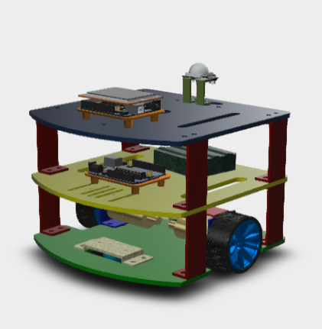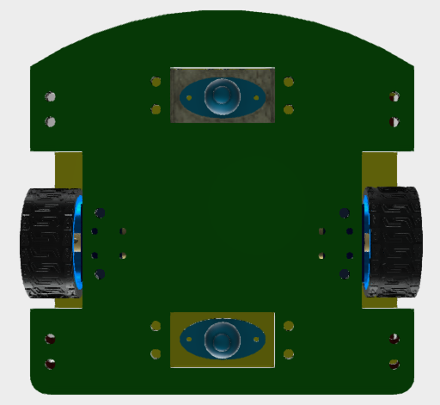

Figure: Two wheels and one lead mobile robot

The popular method controlling this kind of robot is converting the requirement motivation vectors in to two linear velocity vectors of each wheels. This will bring the problem to a simple question: controlling velocity of motors. Here is a simple example of this method:



Figure: Example about controlling method

It is necessary building a dynamic model of the robot in order to have better imagination about motion of robot and wheels. The model had been built as in the following figure:

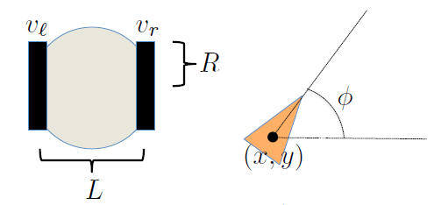

Figure: Dynamic model of mobile robot

Here: $\left\{\begin{aligned}v_{l},v_{r}: Wheels^{'}s velocity \\ R:Wheel^{'}s radius \\ L: Distance between two main wheels \\ x,y,∅:Robot^{'}s position parameters\end{aligned}\right.$

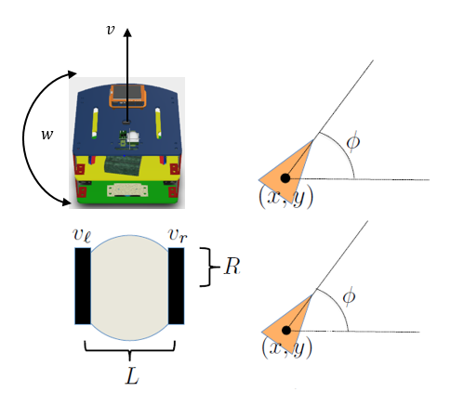From the dynamics model, we build the equations for translational and angular velocities:

Input:

$$\left\{\begin{aligned}v :linear velocity \\ w :angular velocity\end{aligned}\right.$$

Dynamic equations:

$$\left\{\begin{aligned}\dot{x}=v×cos∅ \\ \dot{y}=v×sin∅ \\ \dot{∅}= w\end{aligned} (1) \right.; \left\{\begin{aligned}\dot{x}=\frac{R}{2}(v_{l}+v_{r})×cos∅ \\ \dot{y}=\frac{R}{2}(v_{l}+v_{r})×sin∅ \\ \dot{∅}= \frac{R}{L}×(v_{r}-v_{l})\end{aligned} (2) \right.$$

From eq. (1) and eq. (2):

$\left\{\begin{aligned}\frac{R}{2}(v_{l}+v_{r})×cos∅=v×cos∅ \\ \frac{R}{2}(v_{l}+v_{r})×sin∅=v×sin∅ \\ \frac{R}{L}×(v_{r}-v_{l})= w\end{aligned}\right.$ (3)

Figure: Dynamics model

We have the final equation:

$$\left\{\begin{aligned}v_{r}=\frac{2×v+w×L}{2R} \\ v_{l}=\frac{2×v-w×L}{2R}\end{aligned}\right. (4)$$

Here:

$\left\{\begin{aligned}v_{l},v_{r}:velocity of left wheel and right wheel (mm/s) \\ v:linear velocity (mm/s) \\ w:angular velocity \left(rad/sec\right) \\ L:Distance between two wheels (mm) \\ R:Radian of wheels (mm)\end{aligned}\right.$

## Controlling method

Now, the requirements is taking control the rotation speed and direction of wheels.